PM SHRI JNV PALNADU
Information Practices(065)
XII IP PRACTICAL 2026-27
DATA HANDLING
SERIES
Sno | INDEX | Page.No
1* | Write a Python program to create a Pandas Series using numpy array,dictionary,scalar values
2* | Write a Python program to create a Pandas Series using Indexing and Slicing
3 | Write a Python program to create a Pandas Series using Attributes and Methods
4 | Write a Python program to create a Pandas Series using Mathematical Operations
5 | Write a Python program to create a Pandas Series using loc and iloc
6 | Write a Python program to create a Pandas Series using Filter conditions
DATAFRAME
7 | Write a Python program to Create a Data Frame quarterly sales where each row contains the item category, item name, and expenditure. Group the rows by the category and print the total expenditure per category.
8 | Write a Python program to Create a data frame for examination result and display row labels, column labels data types of each column and the dimensions
9 | Write a Python program for creation of empty ,numpyndarrays.list of dictionaries in pandas dataframe
10 | Write a Python program for a Dictionary of Lists,DataFrame from Series,Dictionary of Series in pandas dataframe
11 | Write a Python program for Operations on rows and columns in DataFrames
12 | Write a Python program for Accessing DataFrames Element through Indexing in DataFrames
13 | Write a Python program for Accessing DataFrames Element through Slicing in DataFrames
14 | Write a Python program using Attributes and Methods of DataFrames
15 | Write a Python program using CSV files in Pandas DataFrames
USING MATPLOTLIB – DATA VISUALIZATION
16 | Given the school result data, analyses the performance of the students on diff erent parameters, e.g subject wise or class wise using LINE chart.
17 | For the Data frames created analyze, and plot appropriate charts with title  and legend using BAR chart
18 | Take data of your interest from an open source (e. data.gov.in), aggregate and  summarize it. Then plot it using different plotting functions of the Matplotlib library.
19 | Write a python program for plotting a HISTOGRAM chart.
MYSQL
20 | MySQL queries using DDL(CARD),DML(UID),DQL(Select) commands in MySQL
21 | MySQL queries using SINGLE FUNCTIONS(Numeric,String,Date)
22 | MySQL queries using AGGREGRATE FUNCTIONS(Max,Min,Sum,Avg,Count(*))
23 | MySQL queries using GROUP BY,HAVING,ORDER BY(ASC,DESC)
24 | MySQL queries using CARTESIAN PRODUCT or CROSS JOIN
25 | MySQL queries using EQUI JOIN & NATURAL JOIN



Practical 1:Write a Python program to create a Pandas Series using numpy array, dictionary, scalar values
Ans:
Source Code:
import pandas as pd
import numpy as np
# 1. Creating Series using NumPy array
a= np.array([10, 20, 30, 40])
s1 = pd.Series(a)
print("Series from NumPy Array:")
print(s1)
# 2. Creating Series using Dictionary
data = {'a': 100, 'b': 200, 'c': 300}
s2 = pd.Series(data)
print("\nSeries from Dictionary:")
print(s2)
# 3. Creating Series using Scalar Value
s3 = pd.Series(5, index=[1, 2, 3, 4])
print("\nSeries from Scalar Value:")
print(s3)

Output:
Series from NumPy Array:
0 10
1 20
2 30
3 40
dtype: int64

Series from Dictionary:
a 100
b 200
c 300
dtype: int64

Series from Scalar Value:
1 5
2 5
3 5
4 5
dtype: int64

Practical 2:Write a Python program to create a Pandas Series using Indexing and Slicing
Ans:
import pandas as pd
data = pd.Series([10, 20, 30, 40, 50]) # Create a Series
# Display the Series
print("Original Series:")
print(data)
# Indexing examples
print("\nAccessing single elements using index:")
print("Element at index 0:", data[0])
print("Element at index 3:", data[3])
# Slicing examples
print("\nAccessing multiple elements using slicing:")
print("Elements from index 1 to 3:")
print(data[1:4]) # elements at index 1,2,3
print("\nElements from beginning to index 2:")
print(data[:3]) # first three elements
print("\nElements from index 2 to end:")
print(data[2:]) # from index 2 to end
Output:
Original Series:
0 10
1 20
2 30
3 40
4 50
dtype: int64
Accessing single elements using index:
Element at index 0: 10
Element at index 3: 40

Accessing multiple elements using slicing:
Elements from index 1 to 3:
1 20
2 30
3 40
dtype: int64
Elements from beginning to index 2:
0 10
1 20
2 30
dtype: int64
Elements from index 2 to end:
2 30
3 40
4 50
dtype: int64

Practical 3: Write a Python program to create a Pandas Series using Attributes and Methods
Ans:
import pandas as pd
# Creating a Series with a name
data = pd.Series([10, 20, 30, 40, 50],index=['A', 'B', 'C', 'D', 'E'],name='Marks')
# Display the Series
print("Series:")
print(data)
# --- Using Attributes ---
print("\nAttributes of Series:")
print("Name:", data.name) # Returns name of the Series
print("Values:", data.values) # Returns all values
print("Index:", data.index) # Returns index labels
print("Data Type:", data.dtype) # Returns data type
print("Size:", data.size) # Returns number of elements
print("Shape:", data.shape) # Returns shape (tuple)
print("Empty:", data.empty) # Checks if the Series is empty
# --- Using Methods ---
print("\nMethods of Series:")
print("Head (first 3 values):")
print(data.head(3)) # Display first 3 elements
print("\nTail (last 2 values):")
print(data.tail(2)) # Display last 2 elements
print("\nSum of elements:", data.sum()) # Sum of all elements
print("Maximum value:", data.max()) # Maximum value
print("Mean value:", data.mean()) # Mean (average)
print("Count (non-NA values):", data.count()) # Counts valid (non-missing) values
Output:
Series:
A 10
B 20
C 30
D 40
E 50
Name: Marks, dtype: int64

Attributes of Series:
Name: Marks
Values: [10 20 30 40 50]
Index: Index(['A', 'B', 'C', 'D', 'E'], dtype='object')
Data Type: int64
Size: 5
Shape: (5,)
Empty: False

Methods of Series:
Head (first 3 values):
A 10
B 20
C 30
Name: Marks, dtype: int64

Tail (last 2 values):
D 40
E 50
Name: Marks, dtype: int64

Sum of elements: 150
Maximum value: 50
Mean value: 30.0
Count (non-NA values): 5

Practical 4:Write a Python program to create a Pandas Series using Mathematical Operations
Ans:
import pandas as pd
import numpy as np
# Creating two Series with NaN (missing) values
s1 = pd.Series([10, 20, np.nan, 40, 50])
s2 = pd.Series([5, np.nan, 15, 20, 25])
# Display the Series
print("Series 1:")
print(s1)
print("\nSeries 2:")
print(s2)
# Performing mathematical operations
print("\nAddition of two Series:")
print(s1 + s2)
print("\nSubtraction of two Series:")
print(s1 - s2)
print("\nMultiplication of two Series:")
print(s1 * s2)
print("\nDivision of two Series:")
print(s1 / s2)

Output:
Series 1:
0 10.0
1 20.0
2 NaN
3 40.0
4 50.0
dtype: float64
Series 2:
0 5.0
1 NaN
2 15.0
3 20.0
4 25.0
dtype: float64
Addition of two Series:
0 15.0
1 NaN
2 NaN
3 60.0
4 75.0
dtype: float64
Subtraction of two Series:
0 5.0
1 NaN
2 NaN
3 20.0
4 25.0
dtype: float64
Multiplication of two Series:
0 50.0
1 NaN
2 NaN
3 800.0
4 1250.0
dtype: float64
Division of two Series:
0 2.0
1 NaN
2 NaN
3 2.0
4 2.0
dtype: float64

Practical 5:Write a Python program to create a Pandas Series using loc and iloc
Ans:
import pandas as pd
import numpy as np
# Creating a Series with some NaN values
marks = pd.Series([85, np.nan, 78, 92, np.nan], index=['eng', 'ip', 'maths', 'phy', 'che'])
print("Marks in subjects (with NaN values):")
print(marks)
# Accessing elements using loc (by index label)
print("\nMarks in ip using loc:", marks.loc['ip']) # NaN
print("Marks in che using loc:", marks.loc['che']) # NaN
# Accessing elements using iloc (by integer position)
print("\nMarks in first subject using iloc:", marks.iloc[0]) # 85
print("Marks in second subject using iloc:", marks.iloc[1]) # NaN
# Accessing multiple elements
print("\nMarks in eng and phy using loc:")
print(marks.loc[['eng', 'phy']])
print("\nMarks in first three subjects using iloc:")
print(marks.iloc[0:3])
# Checking for NaN values
print("\nSubjects with missing marks:")
print(marks[marks.isna()])

Output:
Marks in subjects (with NaN values):
eng 85.0
ipNaN
maths 78.0
phy 92.0
cheNaN
dtype: float64

Marks in ip using loc: nan
Marks in che using loc: nan

Marks in first subject using iloc: 85.0
Marks in second subject using iloc: nan

Marks in eng and phy using loc:
eng 85.0
phy 92.0
dtype: float64

Marks in first three subjects using iloc:
eng 85.0
ip NaN
maths 78.0
dtype: float64

Subjects with missing marks:
ip NaN
che NaN
dtype: float64

Practical 6:Write a Python program to create a Pandas Series using Filter conditions
Ans:
import pandas as pd
# Create a numeric Pandas Series
marks = pd.Series([85, 42, 76, 90, 33, 58, 71, 49])
print("Original Marks Series:")
print(marks)
# Filter: students scoring more than 50
passed = marks[marks > 50]
print("\nStudents scoring more than 50:")
print(passed)
# Filter: students scoring between 50 and 80
range_scores = marks[(marks >= 50) & (marks <= 80)]
print("\nStudents scoring between 50 and 80:")
print(range_scores)
Output:
Original Marks Series:
0 85
1 42
2 76
3 90
4 33
5 58
6 71
7 49
dtype: int64

Students scoring more than 50:
0 85
2 76
3 90
5 58
6 71
dtype: int64

Students scoring between 50 and 80:
2 76
5 58
6 71
dtype: int64



Practical 7: Write a Python program to Create a Data Frame quarterly sales where each row contains the item category, item name, and expenditure. Group the rows by the category and print the total expenditure per category.
Ans:
import pandas as pd
data = {
'Category': ['Electronics', 'Electronics', 'Grocery', 'Grocery', 'Stationery', 'Stationery'],
'Item': ['Smartphone', 'Laptop', 'Rice', 'Sugar', 'Notebook', 'Pen'],
'Expenditure': [25000, 45000, 3000, 1500, 500, 200]
}
df = pd.DataFrame(data)
# Display the original DataFrame
print("Quarterly Sales Data:")
print(df)
# Group by Category and calculate total expenditure per category
grouped = df.groupby('Category')['Expenditure'].sum()
# Display the total expenditure per category
print("\nTotal Expenditure per Category:")
print(grouped)

Output:
Quarterly Sales Data:
Category Item Expenditure
0 Electronics Smartphone 25000
1 Electronics Laptop 45000
2 Grocery Rice 3000
3 Grocery Sugar 1500
4 Stationery Notebook 500
5 Stationery Pen 200

Total Expenditure per Category:
Category
Electronics 70000
Grocery 4500
Stationery 700
Name: Expenditure, dtype: int64

Practical 8:Write a Python program to Create a data frame for examination result and display row labels, column labels data types of each column and the dimensions
Ans:
import pandas as pd
# Create DataFrame for examination result
data = {
'Name': ['Rahul', 'Priya', 'Amit', 'Neha', 'Sonia'],
'Roll_No': [101, 102, 103, 104, 105],
'Marks': [85, 92, 78, 88, 95], 'Grade': ['B', 'A', 'C', 'B', 'A']
}
df = pd.DataFrame(data)
# Display DataFrame
print("Examination Result DataFrame:\n", df)
# Display Row Labels (Index)
print("\nRow Labels (Index):", df.index)
# Display Column Labels
print("Column Labels:", df.columns)
# Display Data Types of each column
print("\nData Types:\n", df.dtypes)
# Display Dimensions of DataFrame (rows, columns)
print("\nDimensions of DataFrame:", df.shape)

Output:
Examination Result DataFrame:
Name Roll_No Marks Grade
0 Rahul 101 85 B
1 Priya 102 92 A
2 Amit 103 78 C
3 Neha 104 88 B
4 Sonia 105 95 A
Row Labels (Index): RangeIndex(start=0, stop=5, step=1)
Column Labels: Index(['Name', 'Roll_No', 'Marks', 'Grade'], dtype='object')
Data Types:
Name object
Roll_No int64
Marks int64
Grade object
dtype: object

Dimensions of DataFrame: (5, 4)
Practical 9:Write a Python program for creation of empty ,numpy ndarrays.list of dictionaries in pandas dataframe.
Ans:
import pandas as pd
import numpy as np
# ---------- 1. Empty DataFrame ----------
empty_df = pd.DataFrame()
print("1. Empty DataFrame:")
print(empty_df)
# ---------- 2. DataFrame from NumPy ndarray ----------
# Create a 2D NumPy array
arr = np.array([[10, 20, 30], [40, 50, 60], [70, 80, 90]])
# Convert ndarray to DataFrame
df_from_array = pd.DataFrame(arr, columns=['Math', 'Science', 'English'])
print("\n2. DataFrame from NumPy ndarray:")
print(df_from_array)

# ---------- 3. DataFrame from list of dictionaries ----------
# Create a list of dictionaries
data = [
{'Name': 'Ravi', 'Age': 16, 'Grade': 'A'},
{'Name': 'Anita', 'Age': 17, 'Grade': 'B'},
{'Name': 'Suresh', 'Age': 16, 'Grade': 'A+'}
]
# Convert list of dictionaries to DataFrame
df_from_dict = pd.DataFrame(data)
print("\n3. DataFrame from list of dictionaries:")
print(df_from_dict)
Output:
1. Empty DataFrame:
Empty DataFrame
Columns: []
Index: []
2. DataFrame from NumPy ndarray:
Math Science English
0 10 20 30
1 40 50 60
2 70 80 90
3. DataFrame from list of dictionaries:
Name Age Grade
0 Ravi 16 A
1 Anita 17 B
2 Suresh 16 A+
Practical 10:Write a Python program for a Dictionary of Lists, DataFrame from Series, Dictionary of Series in pandas DataFrame.
Ans:
import pandas as pd
print("1. DataFrame from Dictionary of Lists:")
data_lists = {
'Name': ['Ravi', 'Anita', 'Suresh', 'Priya'], 'Marks': [85, 92, 78, 88], 'Age': [16, 17, 16, 17]
}
df_lists = pd.DataFrame(data_lists)
print(df_lists)
print("\n2. DataFrame from Series:")
# Create individual Series
names = pd.Series(['Ravi', 'Anita', 'Suresh', 'Priya'])
marks = pd.Series([85, 92, 78, 88])
age = pd.Series([16, 17, 16, 17])
# Create DataFrame by combining Series
df_series = pd.DataFrame({'Name': names, 'Marks': marks, 'Age': age})
print(df_series)
# ---------- 3. DataFrame from Dictionary of Series ----------
print("\n3. DataFrame from Dictionary of Series:")
# Create Series with custom indexes
names_s = pd.Series(['Ravi', 'Anita', 'Suresh', 'Priya'], index=[101,102,103,104])
marks_s = pd.Series([85, 92, 78, 88], index=[101,102,103,104])
age_s = pd.Series([16, 17, 16, 17], index=[101,102,103,104])
# Combine into DataFrame
df_dict_series = pd.DataFrame({'Name': names_s, 'Marks': marks_s, 'Age': age_s})
print(df_dict_series)
Output:
1. DataFrame from Dictionary of Lists:
Name Marks Age
0 Ravi 85 16
1 Anita 92 17
2 Suresh 78 16
3 Priya 88 17
2. DataFrame from Series:
Name Marks Age
0 Ravi 85 16
1 Anita 92 17
2 Suresh 78 16
3 Priya 88 17
3. DataFrame from Dictionary of Series:
Name Marks Age
101 Ravi 85 16
102 Anita 92 17
103 Suresh 78 16
104 Priya 88 17
Practical 11: Write a Python program for Operations on rows and columns in DataFrames
Ans:
import pandas as pd
data = { 'Name': ['Ravi', 'Anita', 'Suresh', 'Priya'],'Marks': [85, 42, 76, 90], 'Age': [16, 17, 16, 18] }
df = pd.DataFrame(data)
print("Original DataFrame:\n",df)
# Access a single column
print("\n Marks Column:\n",df['Marks'])
# Access multiple columns
print("\nName and Age Columns:\n",df[['Name', 'Age']])
#print(df[['Name', 'Age']])
# Add a new column
df['Grade'] = ['A', 'C', 'B', 'A']
print("\nDataFrame after adding Grade column:",df)
# Delete a column
df.drop('Age', axis=1, inplace=True)
print("\nDataFrame after deleting Age column:",df)
# Rename column labels
df.rename(columns={'Marks': 'Score', 'Grade': 'Result'}, inplace=True)
print("\nDataFrame after renaming columns (Marks → Score, Grade → Result):",df)
# Access a single row using index
print("\nRow at index 2:",df.iloc[2])
# Access multiple rows using slicing
print("\nRows from index 1 to 3:",df[1:3])
# Add a new row
new_row = pd.DataFrame({'Name': ['Rahul'], 'Score': [78], 'Result': ['B']})
df = pd.concat([df, new_row], ignore_index=True)
print("\nDataFrame after adding a new row:",df)
# Delete a row by index
df.drop(1, axis=0, inplace=True)
print("\nDataFrame after deleting row at index 1:",df)
# Rename row labels (index)
df.rename(index={0: 'R1', 2: 'R3', 3: 'R4', 4: 'R5'}, inplace=True)
print("\nDataFrame after renaming row labels:",df)

Output:
Original DataFrame:
Name Marks Age
0 Ravi 85 16
1 Anita 42 17
2 Suresh 76 16
3 Priya 90 18
Marks Column:
0 85
1 42
2 76
3 90
Name: Marks, dtype: int64
Name and Age Columns:
Name Age
0 Ravi 16
1 Anita 17
2 Suresh 16
3 Priya 18
DataFrame after adding Grade column:
Name Marks Age Grade
0 Ravi 85 16 A
1 Anita 42 17 C
2 Suresh 76 16 B
3 Priya 90 18 A

DataFrame after deleting Age column:
Name Marks Grade
0 Ravi 85 A
1 Anita 42 C
2 Suresh 76 B
3 Priya 90 A

DataFrame after renaming columns (Marks → Score, Grade → Result):
Name Score Result
0 Ravi 85 A
1 Anita 42 C
2 Suresh 76 B
3 Priya 90 A

Row at index 2:
Name Suresh
Score 76
Result B
Name: 2, dtype: object

Rows from index 1 to 3:
Name Score Result
1 Anita 42 C
2 Suresh 76 B

DataFrame after adding a new row:
Name Score Result
0 Ravi 85 A
1 Anita 42 C
2 Suresh 76 B
3 Priya 90 A
4 Rahul 78 B
DataFrame after deleting row at index 1:
Name Score Result
0 Ravi 85 A
2 Suresh 76 B
3 Priya 90 A
4 Rahul 78 B
DataFrame after renaming row labels:
Name Score Result
R1 Ravi 85 A
R3 Suresh 76 B
R4 Priya 90 A
R5 Rahul 78 B
Practical 12:Write a Python program for Accessing DataFrames Element through Indexing in DataFrames
Ans:
import pandas as pd
# Create a sample DataFrame
data = {
"Name": ["Ravi", "Anita", "Suresh", "Priya", "Rahul"], "Marks": [85, 42, 76, 90, 33], "Age": [16, 17, 16, 17, 16]
}
df = pd.DataFrame(data)
print("Original DataFrame:")
print(df)
# ---------- Accessing using label-based indexing (loc) ----------
# Access a single row by label
print("\nRow with index 2 (using loc):")
print(df.loc[2])
# Access multiple rows and columns by labels
print("\nRows 1 to 3, columns 'Name' and 'Marks' (using loc):")
print(df.loc[1:3, ["Name", "Marks"]])
# ---------- Accessing using position-based indexing (iloc) ----------
# Access a single element (row 0, column 1)
print("\nElement at row 0, column 1 (using iloc):")
print(df.iloc[0, 1])
# Access multiple rows and columns by positions
print("\nRows 0 to 2, columns 0 and 2 (using iloc):")
print(df.iloc[0:3, [0, 2]])
# ---------- Boolean indexing ----------
# Filter students who scored more than 50
print("\nStudents scoring more than 50 (Boolean indexing):")
print(df[df["Marks"] > 50])
# Filter students with Marks > 50 and Age = 16
print("\nStudents with Marks > 50 and Age = 16:")
print(df[(df["Marks"] > 50) & (df["Age"] == 16)])

Output:
Original DataFrame:
Name Marks Age
0 Ravi 85 16
1 Anita 42 17
2 Suresh 76 16
3 Priya 90 17
4 Rahul 33 16

Row with index 2 (using loc):
Name Suresh
Marks 76
Age 16
Name: 2, dtype: object

Rows 1 to 3, columns 'Name' and 'Marks' (using loc):
Name Marks
1 Anita 42
2 Suresh 76
3 Priya 90

Element at row 0, column 1 (using iloc):
85
Rows 0 to 2, columns 0 and 2 (using iloc):
Name Age
0 Ravi 16
1 Anita 17
2 Suresh 16
Students scoring more than 50 (Boolean indexing):
Name Marks Age
0 Ravi 85 16
2 Suresh 76 16
3 Priya 90 17
Students with Marks > 50 and Age = 16:
Name Marks Age
0 Ravi 85 16
2 Suresh 76 16
Practical 13:Write a Python program for Accessing DataFrames Element through Slicing in DataFrames
Ans:
import pandas as pd
# Create a DataFrame
data = {
'Name': ['Amit', 'Riya', 'Karan', 'Neha', 'Tina'], 'Marks': [85, 90, 78, 92, 88],
'Grade': ['B', 'A', 'C', 'A', 'B']
}
df = pd.DataFrame(data, index=['a', 'b', 'c', 'd', 'e'])
# Display the DataFrame
print("Original DataFrame:")
print(df)
# Accessing rows using loc (label-based slicing)
print("\nUsingloc - Rows from label 'b' to 'd':")
print(df.loc['b':'d'])
# Accessing rows using iloc (integer-based slicing)
print("\nUsingiloc - Rows from index 1 to 3:")
print(df.iloc[1:4])
# Accessing specific rows and columns using loc
print("\nUsingloc - Names and Marks from 'b' to 'd':")
print(df.loc['b':'d', ['Name', 'Marks']])
# Accessing specific rows and columns using iloc
print("\nUsingiloc - First 3 rows and first 2 columns:")
print(df.iloc[0:3, 0:2])

Output:
Original DataFrame:
Name Marks Grade
a Amit 85 B
b Riya 90 A
c Karan 78 C
d Neha 92 A
e Tina 88 B
Using loc - Rows from label 'b' to 'd':
Name Marks Grade
B Riya 90 A
c Karan 78 C
dNeha 92 A
Using iloc - Rows from index 1 to 3:
Name Marks Grade
b Riya 90 A
c Karan 78 C
d Neha 92 A
Using loc - Names and Marks from 'b' to 'd':
Name Marks
b Riya 90
c Karan 78
d Neha 92
Using iloc - First 3 rows and first 2 columns:
Name Marks
a Amit 85
b Riya 90
c Karan 78
Practical 14:Write a Python program using Attributes and Methods of DataFrames
Ans:
import pandas as pd
# Create a simple DataFrame
data = {
'Name': ['Amit', 'Riya', 'Karan', 'Neha'], 'Age': [17, 18, 16, 17], 'Marks': [88, 92, 79, 85]
}
df = pd.DataFrame(data)
print("Original DataFrame:")
print(df)
print()
#---------------- ATTRIBUTES ----------------
print("ATTRIBUTES OF DATAFRAME:")
print("Index :", df.index) # Row index labels
print("Columns :", df.columns) # Column labels
print("Data Types:\n", df.dtypes) # Data type of each column
print("Values :\n", df.values) # All data as 2D array
print("Shape :", df.shape) # (rows, columns)
print("Size :", df.size) # Total number of elements
print("Transpose (df.T):\n", df.T) # Transposed DataFrame
print("Number of Dimensions:", df.ndim) # Dimension of DataFrame
print("Is DataFrame Empty?:", df.empty) # Check if DataFrame is empty
print()
# ---------------- METHODS ----------------
print("METHODS OF DATAFRAME:")
print("Head (first 2 rows):\n", df.head(2)) # Display first 2 rows
print("Tail (last 2 rows):\n", df.tail(2)) # Display last 2 rows
print("Length of DataFrame using len():", len(df)) # Number of rows
print("Count of Non-Null Values in Each Column:\n", df.count()) # Count non-null
print("Axes of DataFrame:", df.axes) # Row and column index objects
Output:
Original DataFrame:
Name Age Marks
0 Amit 17 88
1 Riya 18 92
2 Karan 16 79
3 Neha 17 85

ATTRIBUTES OF DATAFRAME:
Index : RangeIndex(start=0, stop=4, step=1)
Columns : Index(['Name', 'Age', 'Marks'], dtype='object')
Data Types:
Name object
Age int64
Marks int64
dtype: object
Values :
[['Amit' 17 88]
['Riya' 18 92]
['Karan' 16 79]
['Neha' 17 85]]
Shape : (4, 3)
Size : 12
Transpose (df.T):
0 1 2 3
Name Amit Riya Karan Neha
Age 17 18 16 17
Marks 88 92 79 85
Number of Dimensions: 2
Is DataFrame Empty?: False

METHODS OF DATAFRAME:
Head (first 2 rows):
Name Age Marks
0 Amit 17 88
1 Riya 18 92
Tail (last 2 rows):
Name Age Marks
2 Karan 16 79
3 Neha 17 85
Length of DataFrame using len(): 4
Count of Non-Null Values in Each Column:
Name 4
Age 4
Marks 4
dtype: int64
Axes of DataFrame: [RangeIndex(start=0, stop=4, step=1), Index(['Name', 'Age', 'Marks'], dtype='object')]
Practical 15:Write a Python program using CSV files in Pandas DataFrames
Ans:
import os
print(os.getcwd())
import pandas as pd
# ---------------- EXPORTING DATAFRAME TO CSV ----------------
# Create a simple DataFrame
data = {
'Name': ['Amit', 'Riya', 'Karan', 'Neha'],
'Age': [17, 18, 16, 17],
'Marks': [88, 92, 79, 85]
}
df = pd.DataFrame(data)
print("Original DataFrame:")
print(df)
# Export the DataFrame to a CSV file
df.to_csv("students.csv", index=False)
print("\nDataFrame has been successfully exported to 'students.csv'.")
print()
# ---------------- IMPORTING DATAFRAME FROM CSV ----------------
# Read the CSV file into a new DataFrame
new_df = pd.read_csv("students.csv")
print("Data imported from CSV file:")
print(new_df)

Output:
Original DataFrame:
Name Age Marks
0 Amit 17 88
1 Riya 18 92
2 Karan 16 79
3 Neha 17 85

DataFrame has been successfully exported to 'students.csv'.

Data imported from CSV file:
Name Age Marks
0 Amit 17 88
1 Riya 18 92
2 Karan 16 79
3 Neha 17 85

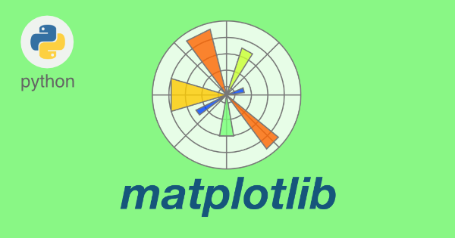

Practical 16:Given the school result data, analyses the performance of the students on different parameters, e.g subject wise or class wise using LINE chart.
Ans:
import pandas as pd
import matplotlib.pyplot as plt
# Subjects and corresponding marks
subject = ['English', 'IP', 'Maths', 'Physics', 'Chemistry']
marks = [80, 75, 70, 78, 77]
# Plotting the line chart with legend
plt.plot(subject, marks,
color='green', # Line color
marker='*', # Star marker
markerfacecolor='red', # Fill color for marker
markeredgecolor='red', # Border color for marker
markersize=12, # Size of marker
linewidth=2, # Thickness of the line
label='Marks Obtained') # Legend label
# Adding title and axis labels
plt.title('Marks Scored')
plt.xlabel('SUBJECT')
plt.ylabel('MARKS')
# Adding custom ticks
plt.xticks(subject)
plt.yticks([70, 72, 74, 76, 78, 80, 82])
# Adding legend (placed at best location automatically)
plt.legend(loc='best', fontsize=10, frameon=True, shadow=True)
# Save the chart as an image
plt.savefig("d:\\line.png")
# Display the chart
plt.show()
Output:
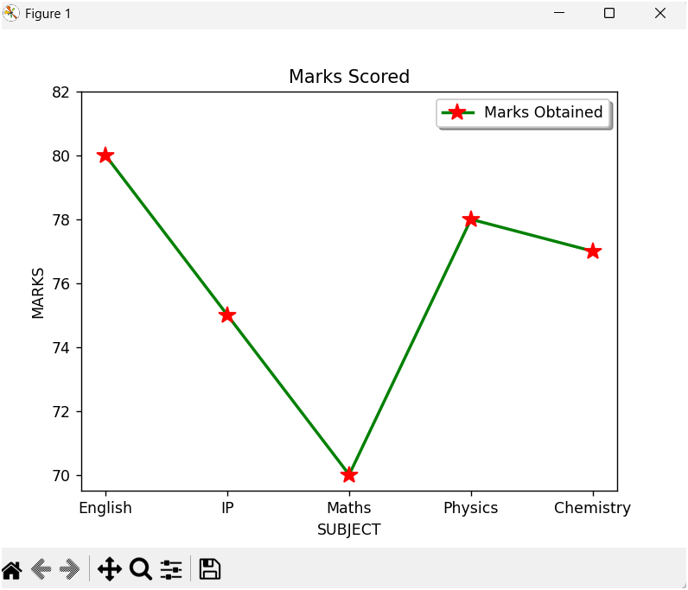

Practical 17:For the Data frames created analyze, and plot appropriate charts with title and legend using BAR chart
Ans:
import pandas as pd
import matplotlib.pyplot as plt
df=pd.read_csv("D:\\Mela3.csv")
#creates plot of different color for each week
df.plot(kind='bar',x='Day',title='Mela Sales Report', color=['red','yellow','purple'], edgecolor='green',linewidth=2,linestyle='--')
plt.title('Mela Sales Report')
plt.xlabel('Days')
plt.ylabel('Sales in Rs')
plt.savefig("d:\\ex.png")
plt.show()

Output:
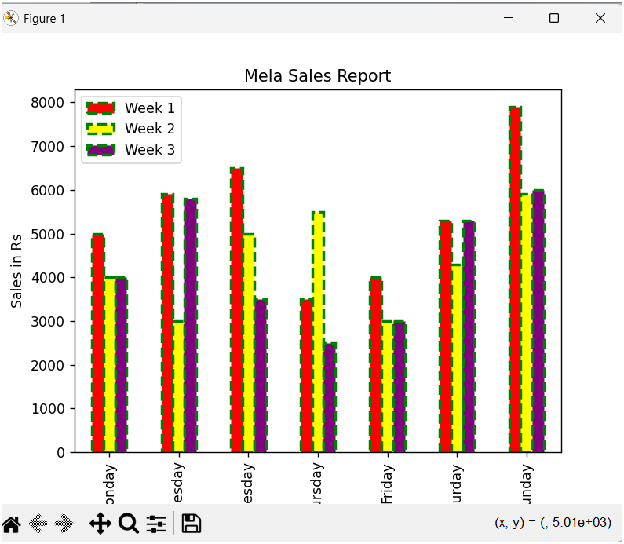

Practical 18:Take data of your interest from an open source (e. data.gov.in), aggregate and summarize it. Then plot it using different plotting functions of the Matplotlib library.
Ans:
First create CSV files below
State/UT,Total Doses Administered,People Vaccinated
Delhi,1200000,600000
Maharashtra,2500000,1250000
Karnataka,1800000,900000
Tamil Nadu,1600000,800000
Kerala,1400000,700000
And save as ex.csv
import pandas as pd
import matplotlib.pyplot as plt
# Step 1: Load the dataset
df = pd.read_csv('d:\\ex.csv')
# Step 2: Data Preprocessing
# Assuming the dataset has columns 'State/UT', 'Total Doses Administered', and 'People Vaccinated'
df = df[['State/UT', 'Total Doses Administered', 'People Vaccinated']]
# Step 3: Aggregation
# Sorting the data by 'Total Doses Administered'
df_sorted = df.sort_values(by='Total Doses Administered', ascending=False)
# Step 4: Visualization
# Line Plot
plt.figure(figsize=(10, 6))
plt.plot(df_sorted['State/UT'], df_sorted['Total Doses Administered'], marker='o', linestyle='-', color='b')
plt.title('COVID-19 Vaccination: Total Doses Administered by State/UT')
plt.xlabel('State/UT')
plt.ylabel('Total Doses Administered')
plt.xticks(rotation=90)
plt.grid(True)
plt.tight_layout()
plt.show()
# Bar Chart
plt.figure(figsize=(10, 6))
plt.bar(df_sorted['State/UT'], df_sorted['Total Doses Administered'], color='g')
plt.title('COVID-19 Vaccination: Total Doses Administered by State/UT')
plt.xlabel('State/UT')
plt.ylabel('Total Doses Administered')
plt.xticks(rotation=90)
plt.tight_layout()
plt.show()
# Histogram
plt.figure(figsize=(10, 6))
plt.hist(df_sorted['Total Doses Administered'], bins=10, color='r', edgecolor='black')
plt.title('Distribution of Total Doses Administered')
plt.xlabel('Total Doses Administered')
plt.ylabel('Frequency')
plt.tight_layout()
plt.show()
Output: It will display all 3 types of charts Line,Bar,Histogram graph
LINE CHART
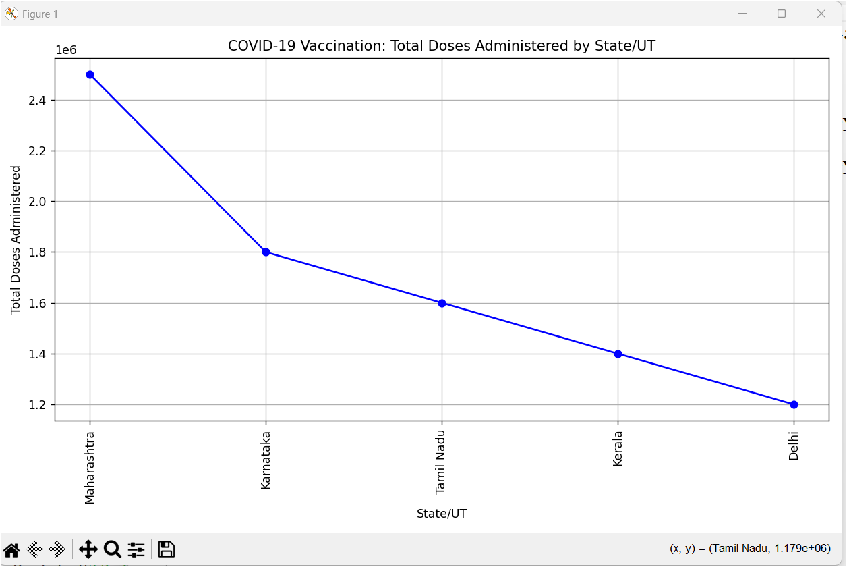

BAR CHART
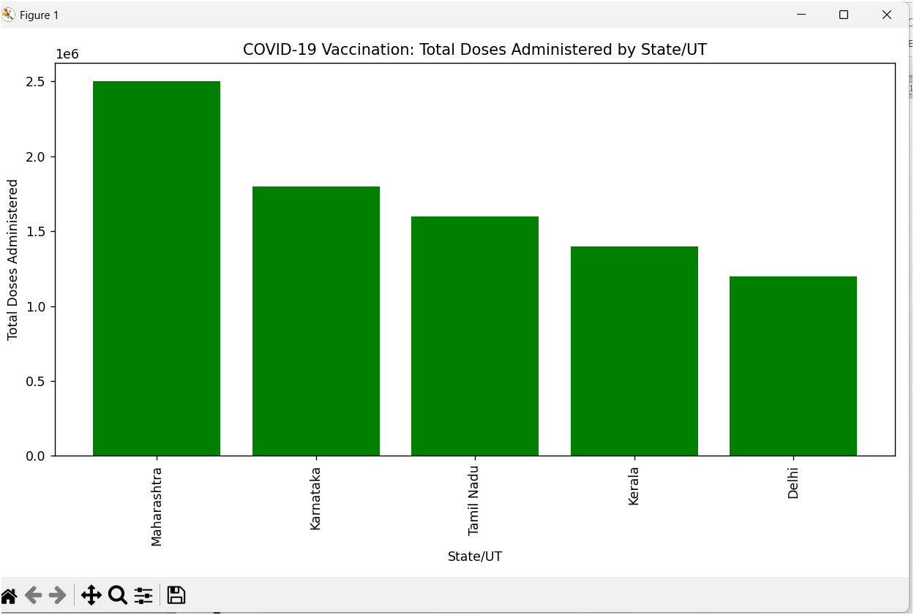
HISTOGRAM
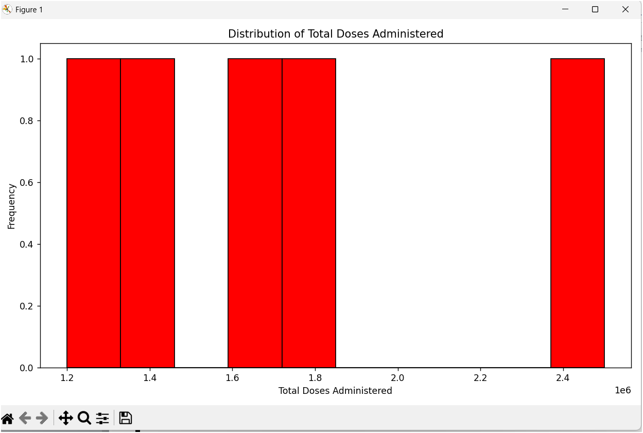
Practical 19: Write a python program for plotting a HISTOGRAM chart.
Output:
import matplotlib.pyplot as plt
# Marks of 20 students in a test (out of 40)
marks = [12, 25, 18, 30, 22, 35, 28, 14, 10, 26,
32, 19, 15, 38, 21, 17, 24, 29, 27, 36]
# Plot Histogram (Normal frequency distribution)
plt.hist(
marks,
bins=[0, 10, 20, 30, 40], # class intervals (0–10,10–20,20–30,30–40)
cumulative=False, # normal frequency (not cumulative)
histtype='bar', # default bar style
align='mid', # bins aligned at mid
orientation='vertical', # vertical histogram
color='lightcoral', edgecolor='black'
)
# Add labels and title
plt.xlabel("Marks (out of 40)")
plt.ylabel("Frequency")
plt.title("Histogram of Student Marks (20 Students)")
# Save figure as PNG file
plt.savefig("D:\\H.png", dpi=300)
# Show plot
plt.show()
Output:
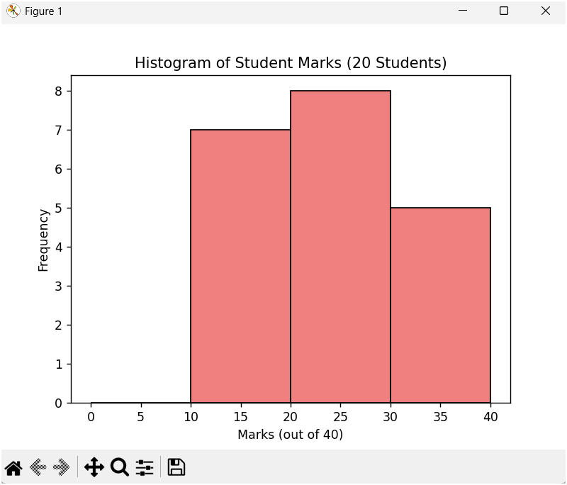

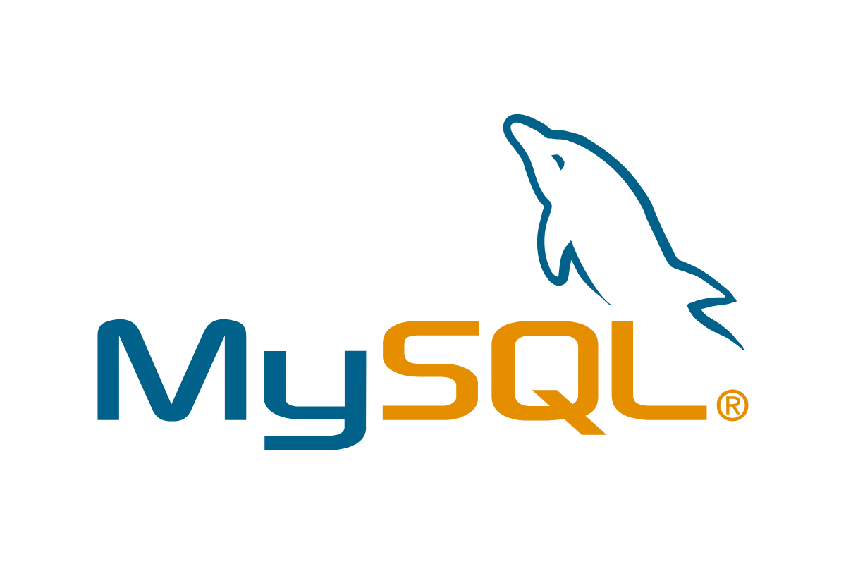

Practical 20:MySQL queries using DDL(CARD),DML(UID),DQL(Select) commands in MySQL
- Write a Query to Create a new database in the name of XII
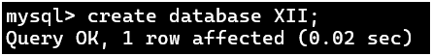
- Write a Query to Open the database XII.

(c) Write a Query to list all the existing database names.SHOW DATABASES;
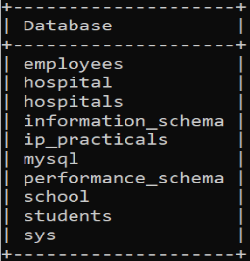
- Write a Query to create the table called: Student
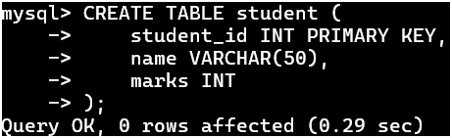

- Write a Query to List all the tables that exists in the current database.
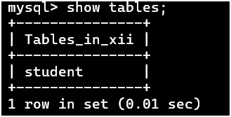
(f)Write a Query to insert all the rows of into student table
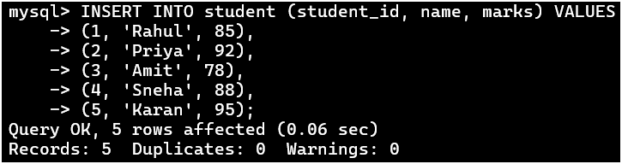

(g)Write a Query to display all the details of the Employees from the table 'STUDENT'.
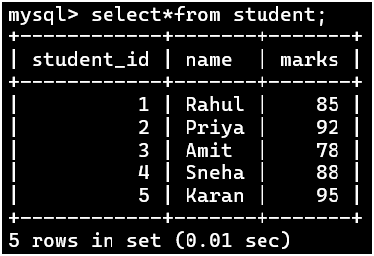
(h)Write a Query tomodify the structure of the table using Alter command
(i) Write a Query to update the values in student table for DOB using UPDATE command

(j) Write a Query to delete the values in student table for rahul using DELETE command
(k)Write a Query to RENAME table
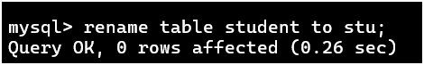
(l) Write a Query to DROP the table;
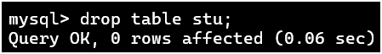
Practical 21:MySQL queries using SINGLE FUNCTIONS(Numeric,String,Date)
Ans:
mysql>CREATE TABLE emp ( empno INT PRIMARY KEY,ename VARCHAR(30), sal DECIMAL(10,2), deptno INT);
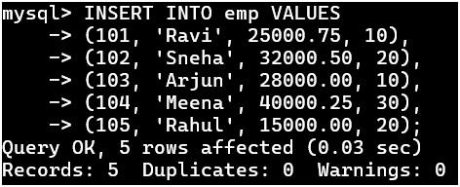
NUMERIC FUNCTIONS:

Using POWER
Using ROUND

Using MOD

STRING FUNCTIONS
Using LOWER,UPPER
Using SUBSTR,LENGTH
Using LEFT,RIGHT
Using TRIM,LTRIM,TRIM
Using INSTR
DATE FUNCTIONS
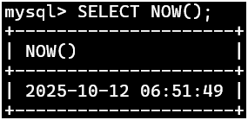
Using NOW()

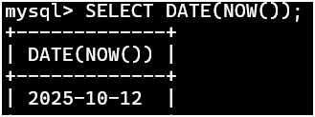
Using DATE()

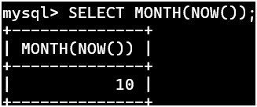
Using MONTH()

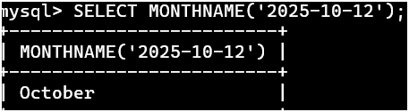
Using MONTHNAME

Using YEAR,DAY,DAYNAME

Practical 22: MySQL queries using AGGREGRATE FUNCTIONS(Max,Min,Sum,Avg,Count(*))

Ans: Create table STUD
mysql>>CREATE TABLE stud(rno INT PRIMARY KEY, name VARCHAR(50), class INT, eng INT, ip INT, mat INT, phy INT, che INT, total_marks INT, grade CHAR(2));
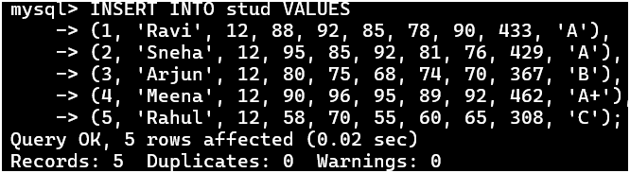
Insert Values in table

Use Aggregrate Functions from above table
Max:
Min :
Avg
Sum

Count (*)

Note :to use count function update the any value from table
Count

Practical 23: MySQL queries using GROUP BY,HAVING,ORDER BY(ASC,DESC)
Ans:
Ans: Create table STUD
Insert Values in table

Use GROUP BY,HAVING,ORDER BY(ASC,DESC)from above table
Group By:

Having:

Order By(ASC/DESC):

Group By + Having + Order By

Practical 24:MySQL queries using CARTESIAN PRODUCT or CROSS JOIN
Ans:Create 2 tables

Using Cartesian Product

Cartesian Product with a Filtering Condition

Practical 25:MySQL queries using EQUI JOIN & NATURAL JOIN
Ans:Create Two tables

Insert Values
EQUI JOIN (using WHERE or INNER JOIN)
Display student name and marks using EQUI JOIN
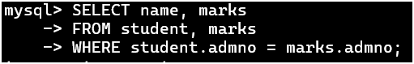
Display all data using EQUI JOIN
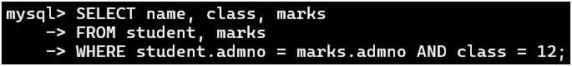
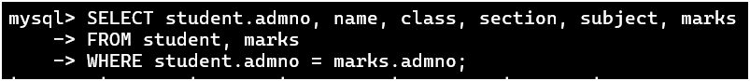
Display students of class 12 with their marks
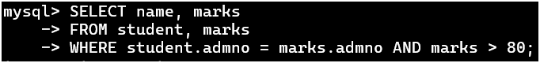
Display students who scored more than 80
Display same query using INNER JOIN (alternative to EQUI JOIN)
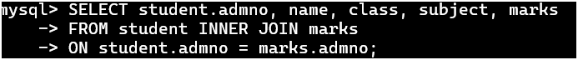
Display all data using NATURAL JOIN

Display name and marks of all students
Display name, class, and marks of students of class 12
